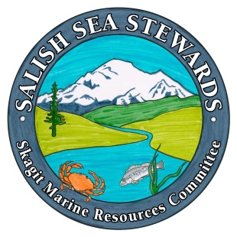
Skagit Marine Resources Committee
Salish Sea Stewards Volunteer Training
Volunteer Application

Name:
Mailing Address:
Phone:
Email address:
Are you able to fulfill the 40 hour volunteer commitment over the next year? Yes No
Please list the times you would not be available for volunteer work or training: (work schedules, anticipated trips, other commitments) to the best of your ability: I anticipate being able to make all of the training.
How did you hear about Salish Sea Steward Volunteer Training?

Training/Education completed:
School (major studies):
Relevant degrees, training, or certifications (specify):
What areas are you most interested in learning about/volunteering for? (Check all that apply)

- Monofilament Recovery
- Beach Seining
- Fidalgo Bay Day
- Forage Fish Surveys
- Intertidal Monitoring
- Native Oyster Surveys
- Aquarium Guide
- Green Crab Surveys
- Education & Outreach
- Library Support
- Water Quality Sampling
- Education & Outreach/Special Events
- Beach cleanups
- Zero Waste
- Bull Kelp Surveys
- Heron Observations
- Beach Naturalist
- Crabber Outreach
- Plankton Monitoring
- Beach Surveys
- Volunteer Coordination
- Project Leader
- Program Administration
- Photographer
- Communications, social media, website, newsletters, etc.
- Other?____________

Would you be interested in being trained to become a volunteer leader for a project? Yes No
(This is not a commitment, we are just gauging interest)

Please describe your experience with citizen science, environmental volunteering and public interpretation: (personal, volunteer or work experience):

List your other volunteer experience:

Other skills, interests or experience (please check all that apply):

- Computers
- Website maintenance
- Artwork/Displays
- Photography
- Drawing/Illustrating
- Writing/Publishing
- Marketing/Fundraising
- Research/Data Collection
- Public Speaking/Teaching
- GPS/GIS
- Boating Skills
- Microscopy
- Woodworking
- Docent
- Trail Guide
- Public Interpretation
- Program Development
- Grant Writing

Please provide specific information on the above checked categories: ___________________________
_______________________________________________________________________________________________________________________________________________________________________________________________________________________________________________________________
Why do you wish to become a Salish Sea Steward?

Any other information about your skills and abilities you would like us to know?

Photo/Video release
In the event your picture is taken during a Salish Sea Stewards event or training, do you give the Skagit County Marine Resources Committee (SMRC) permission for that picture or video sequence to be used in SMRC brochures, publications or websites? Please check one of the boxes below:
- Yes- I DO give the SMRC permission to use my photographic and/or video likeness taken during any SMRC event or anywhere I am representing the SMRC as a Salish Sea Stewards trainee, intern or Salish Sea Stewards Volunteer, by any means and without limit for education, demonstration, and promotional purposes.
- No-I DO NOT give the SMRC permission to use my photographic and/or video likeness taken during any SMRC event or anywhere I am representing the SMRC as a Salish Sea Stewards trainee, intern or Salish Sea Stewards Volunteer, by any means and without limit for education, demonstration, and promotional purposes.

Requirements & Commitments
- Attend all Salish Sea Stewards classes which will be held every Tuesday, 1- 5 PM at the Padilla Bay Reserve. A training syllabus will be provided on first day of class. We will work with you if you must miss a class, but we ask that you seriously consider your availability as class space is limited.
- Provide at least 40 hours of service on any SMRC or partner volunteer projects or activities within one year of completing the Salish Sea Stewards training.
- Record and report your 40 hours of volunteer service using Volgistics online database. Volgistics training will be provided during the class.
- Acknowledge that photos and video recordings may be made during classes, events and activities, and that this material may be used in whole or in part by the Skagit County Marine Resources Committee.

If accepted into the Salish Sea Stewards volunteer training program, I agree to complete the training program required of all volunteers, and I agree to the terms and conditions listed in the Requirements & Commitments section above.

Applicant Signature: ________________________________________ Date: _____________
(Your printed signature is acceptable if emailing the application)

Completed applications can be e-mailed to salishseastewards@gmail.com or mailed to:
Padilla Bay NERR
Attn: Salish Sea Stewards Training Coordinator
10441 Bayview Edison Rd
Mount Vernon, WA 98273

Applications are due March 1, 2020
If you are mailing your application, we recommend a February 28 postmark.

Questions about the program can be directed to salishseastewards@gmail.com

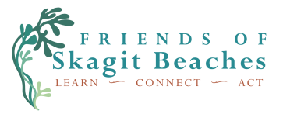
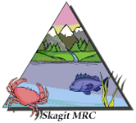
The Salish Sea Stewards is a program of the Skagit Marine Resources Committee with support from Padilla Bay National Estuarine Research Reserve (NERR) and Friends of Skagit Beaches. It has been funded wholly or in part by the United States Environmental Protection Agency under Assistance Agreement [CE-01J65401]. The contents of this document do not necessarily reflect the views and policies of the Environmental Protection Agency, nor does mention of trade names or commercial products constitute endorsement or recommendation for use.

